HEDY LAMARR AND THE DESCENT OF ART RESTORATION BY LASER

John F. Asmus
Research Physicist
Institute for Pure and Applied Physical Sciences
University of California, San Diego

Abstract

Laser divestment entered the field of art conservation through a bizarre sequence of positive accidental events (serendipity) that involved the cinema industry, the invention of spread-spectrum and frequency-hopping communications, nuclear space propulsion, and oceanography. The unlikely chain of events began with the invention of a secure military communications system by a Viennese motion picture actress (1942). A first evaluation of the novel communication concept took place during a high-altitude nuclear test (TEAK) over the Pacific Ocean in 1958. The secure radio link proved to be a failure; however, analyses of the backscattered electromagnetic radiation contributed to the realization that nuclear-explosion plasmas need not be spherically symmetrical. Nobel Laureate Freeman Dyson exploited this nuclear option to guide in the design and prototype development of the ORION Spaceship that was to rendezvous with the planet Saturn in 1970. For this space vehicle the high-specific-impulse nuclear propulsion was generated by means of super-radiant x-ray-beam ablation of the spaceship’s rear surface by the remote detonation of a sequence of asymmetrical bombs projected reward from the ORION. In the wake of the Nuclear Test Ban Treaty (1962) ORION was canceled. Through a Scripps Institution of Oceanography project in Venice (involving ORION-dedicated diagnostic holographic technology) the nondestructive radiation-ablation process found a resurrection in the field of stone conservation (1972). Ironically, the first major art-conservation project to employ laser ablation (Porta della Carta of the Palazzo Ducale) was paid for in part by Warner Brothers Motion Picture Studios (1980). Finally, the “Venice laser statue cleaner” followed the Viennese actress (Hedy Lamarr/Hedwig Eva Maria Kiesler) to Hollywood where it was employed to treat the granite veneer of the Warner Center (1981).

Introduction
The fields of art conservation and laser science merged, formally and fittingly, in the land of Polyclitus and Democritus with a 1995 event now called LACONA I (Lasers for the CONservation of Art, held at the FORTH Center in Heraclion). However appropriate that symbolic recognition of the sources of western cultural heritage may seem, the most recent LACONA VI Conference (September 2005) has, in Vienna, returned to the direct technological genesis of lasers in the service of art. The implausible trajectory of “unintended consequences” that led to the introduction of laser technology into art conservation was triggered in 1941-42 when Viennese cinema actress Hedy Lamarr invented a novel (jamming proof) concept for the radio transmission of guidance information to naval torpedoes.

Subsequent decades witnessed initial evaluations of the Lamarr modulation schemes that helped uncover new avenues in nuclear weapons design as well as in the invention of the nuclear-propelled spaceship (ORION). Subsequently, the holographic plasma diagnostics developed for the engineering design of the spaceship were applied to the in-situ archival recording of deteriorating Venetian statuary. This, in turn, led to the improbable realization that the radiation-propulsion mechanism of ORION could provide a means of self-limiting divestment (and conservation) of crumbling marble statues.

The series of “connections” and happy accidents that helped in bringing about LACONA VI are summarized in the sections that follow.

Hedy Lamarr and her communications patent
In 1942 Viennese motion picture actress Hedy Lamarr (Hedwig Eva Maria Kiesler) of the MGM Motion Picture Studios was granted US patent #2.292,387 for a “Secret Communication System” (Figure 1) based on her invention of spread-spectrum and frequency-hopping concepts. (Curiously, at MIT Prof. Claude Shannon and his student, Irwin Jacobs, were independently formulating, at the same time, the information theory basis that eventually validated her design.) Evidently, Lamarr’s idea was a merging of art and science in that it sprang from her knowledge of the military business of her former Viennese husband, Fritz Mandl, and her technical understanding (gained from her friendship with DaDa artist George Antheil) of Antheil's performance art piece involving sixteen interconnected player pianos. The Antheil player piano performance is known as “Ballet Mecanique” (Figure 1 inset).

As Lamarr’s concept became the basis of cell phone technology, Wi-Fi protocols, and the wireless Internet, she won a US$1/4M

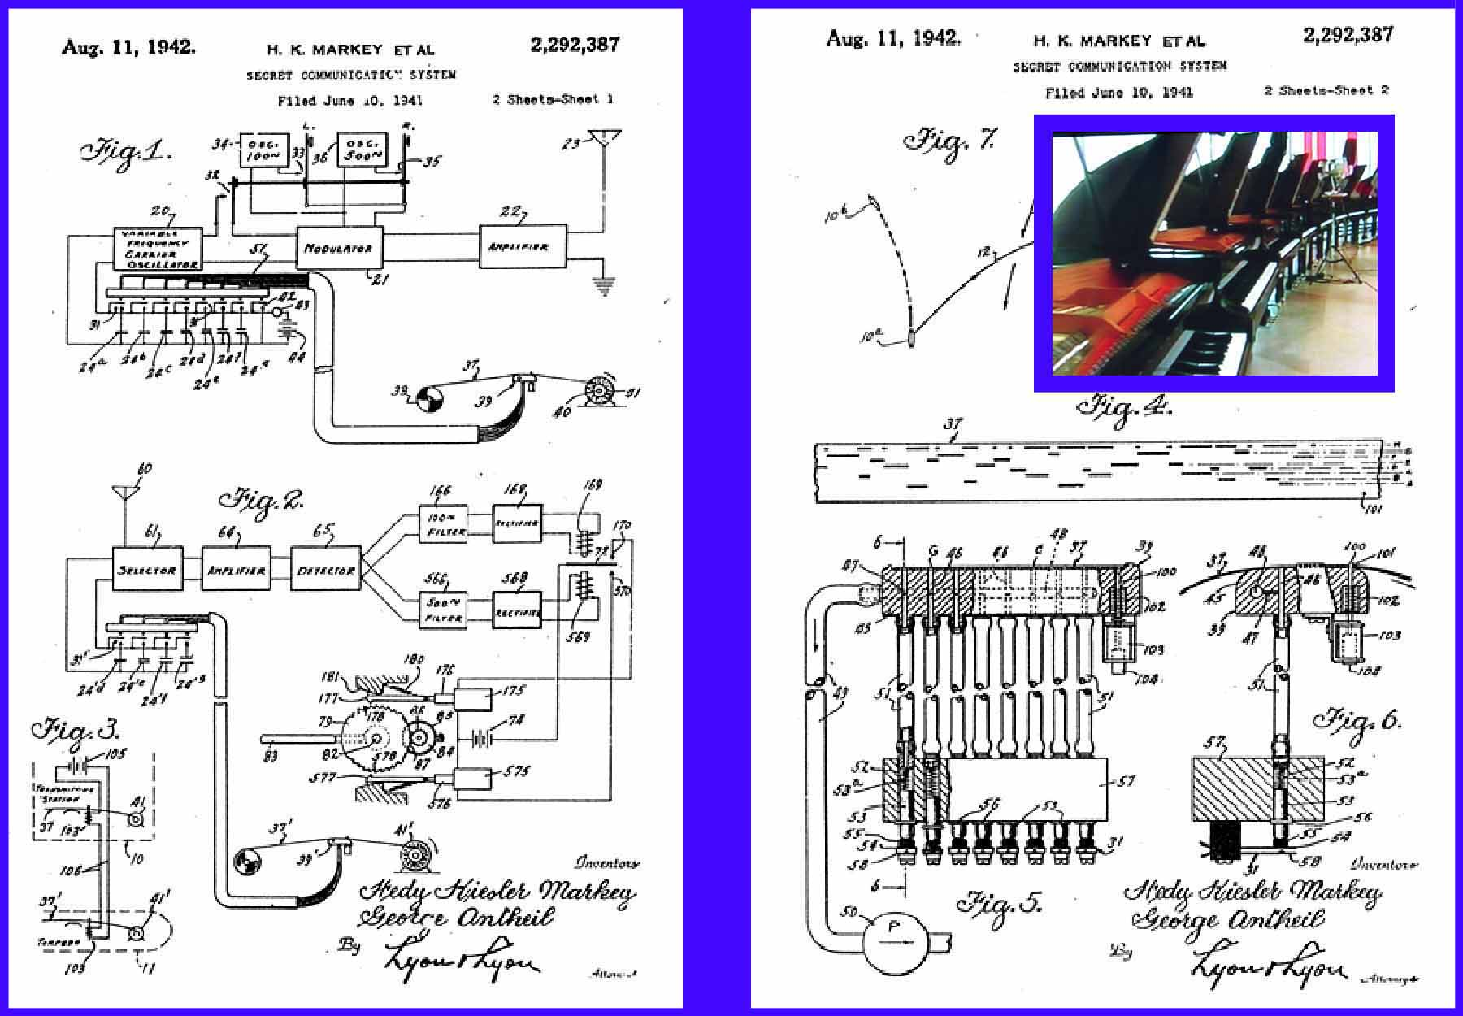

Fig. 1. MGM motion picture star Hedy Lamarr’s first patent pages for “A Secret Communication System” that introduced the frequency-hopping and spread-spectrum concepts to the communications field. The inset shows a portion of the interconnected player piano array of George Antheil’s “Ballet Mecanique” that provided the inspiration for Lamarr’s concept.

infringement claim against Corel Corporation before her patent expired. She also received the 1997 Electronic Frontier Award. Upon receiving the award, 55 years after the fact, her response, “..it’s about time..”, received almost as much notice as her “au naturel” appearance in the 1933 Czech film, “Ecstasy”.

The first evaluation of Hedy Lamarr’s “secure communications system” was carried out by the direct recipient of her patent rights: the U.S. Navy. The U.S. Naval Ordnance Laboratory carried out transmission tests (Project ARGUS) between Hawaiian Pacific Ocean Islands in 1958 (Figure 2) during the Johnston Island high-altitude nuclear explosion TEAK (3.8Mt at 77km altitude). Disappointingly, the experimental radio-wave transmission link was

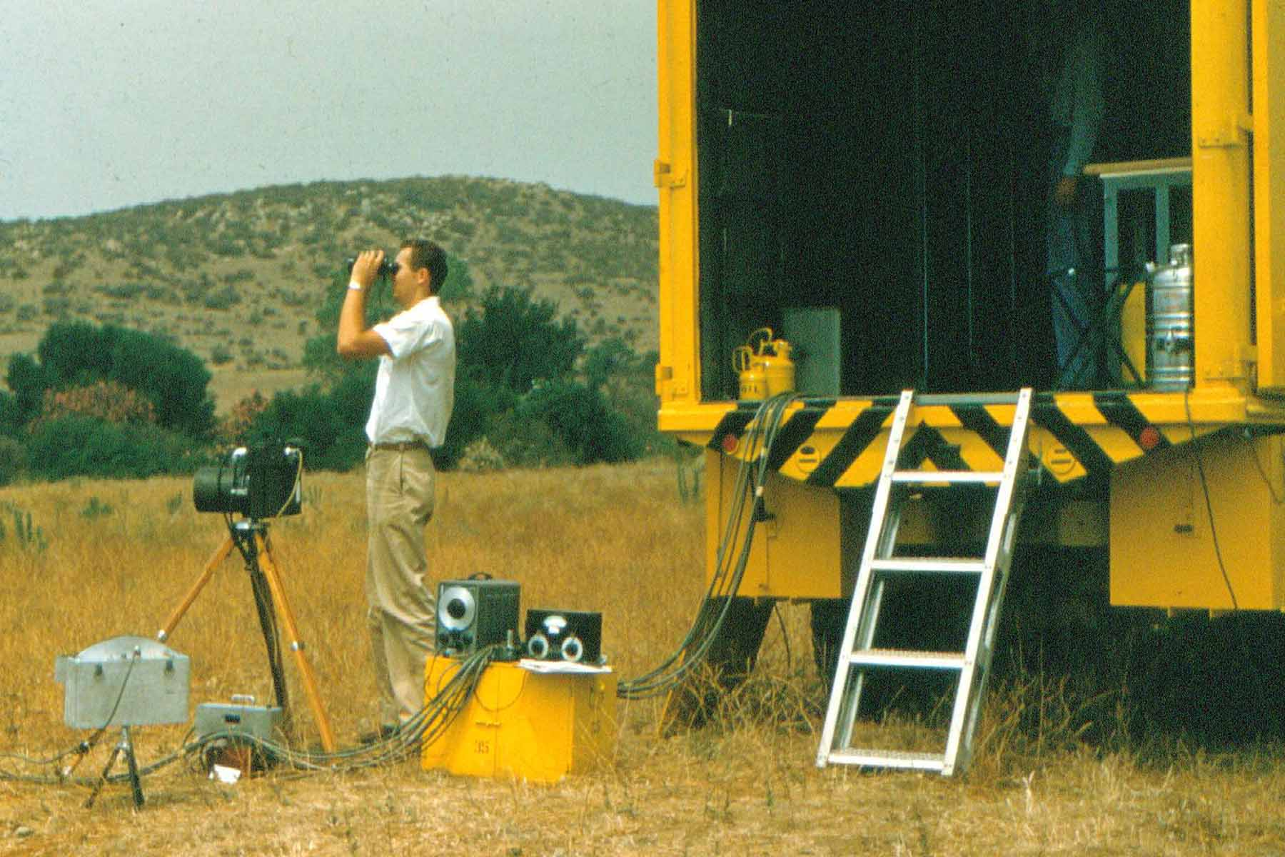

Fig. 2. Spread-spectrum Project ARGUS receiver site on the Island of Niihau, Hawaii (1958) at the time of the high-altitude H-bomb explosion known as TEAK.

completely “blacked out” by the bomb’s gamma-ray-induced aurora. However, spectral analyses of the backscattered electromagnetic signal revealed that the H-bomb had, through a performance asymmetry, ejected a plasma jet.

Orion: nuclear spaceship
The ARGUS backscatter data supported other independent theoretical and experimental results predicting that nuclear explosive devices embodied the potential for being redesigned into directed-energy radiation sources. Upon this realization, members of the TEAK team joined with the teams of theoretical physicist Freeman Dyson and virtuoso mini-bomb designer Theodore Taylor to exploit and optimize this phenomenon in order to develop a nuclear-propelled spaceship, ORION, for a mission to the planet Saturn (scheduled for 1970). Following a first ORION test flight (1962), the adoption of the Nuclear Test-Ban Treaty led to the cancellation of the program. Figure 3 displays two examples of test results from laboratory proof-of principle ORION technology demonstrations revealing the impulsive force that may be delivered to a surface by radiation ablation.

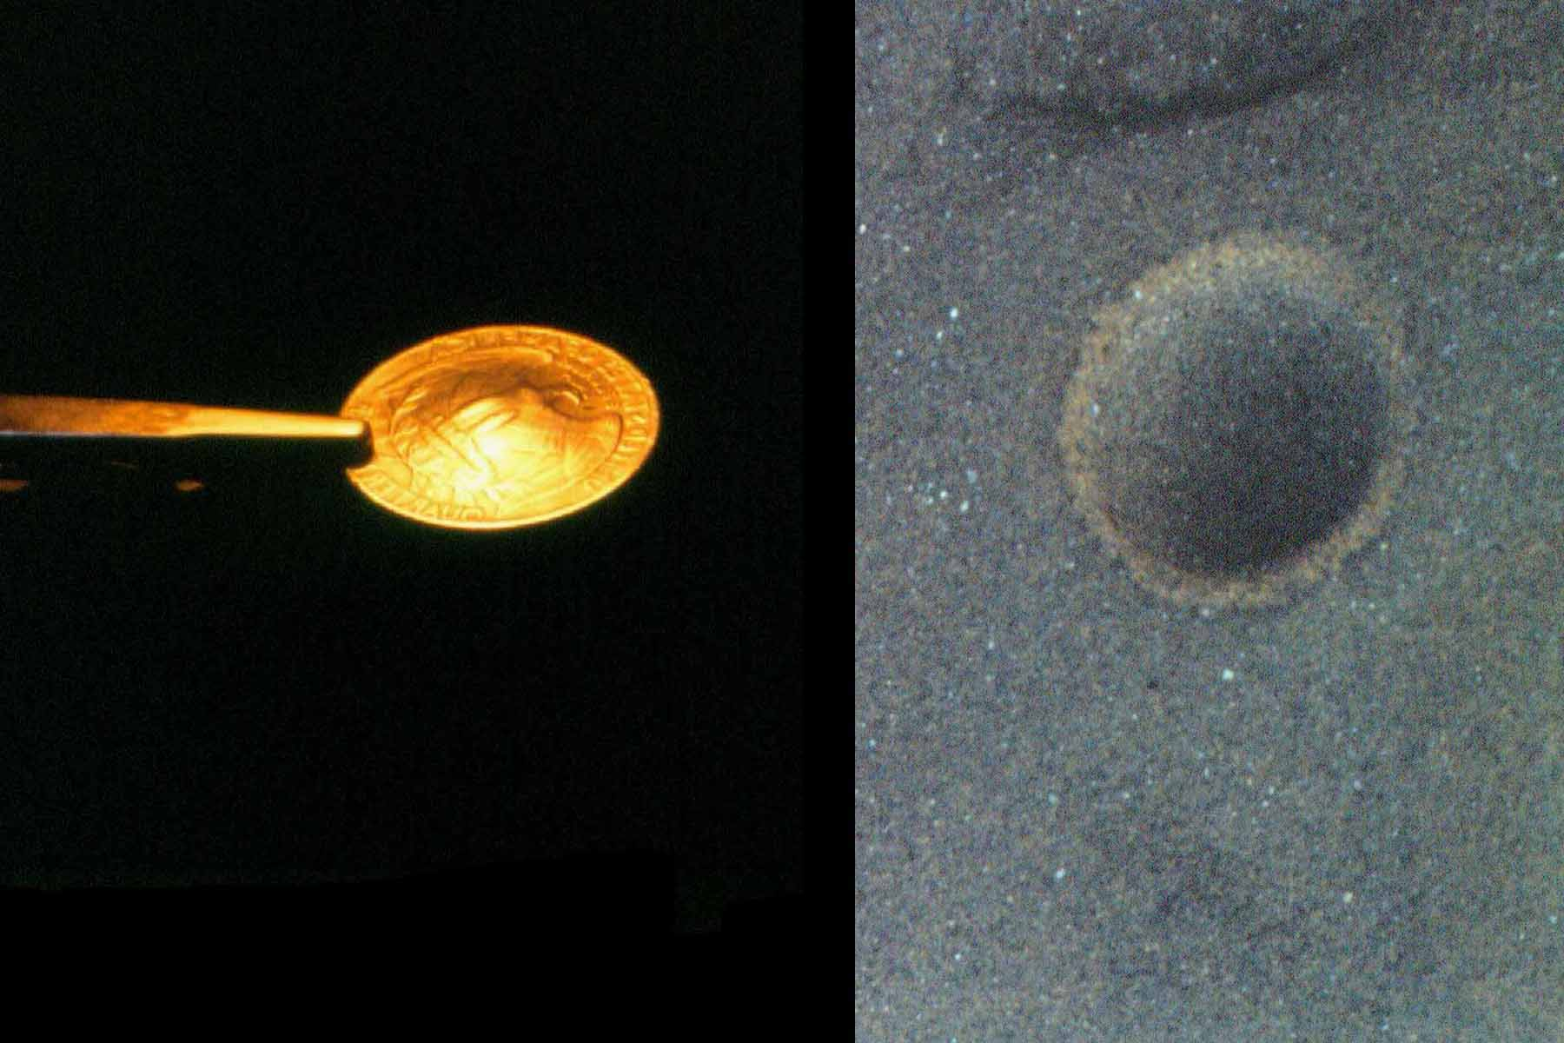

Figs. 3. Deformation of a restrained metallic coin through the impulse delivered by laser ablation pressure at a multigigawatt and kilojoule level (left) and a hypervelocity impact crater produced by the energy released through the impact of a laser-propelled projectile (right).
Figure 4 presents a conceptual rendering of the ORION space vehicle passing by Mars on its anticipated 1970 journey to Saturn. Eventually, several ORION concepts and test results were exploited by, and incorporated into, ICF (Inertial-Confinement thermonuclear plasma Fusion) and X-ray laser programs.

Laser divestment in Venice
The real-time ruby-laser holographic diagnostic system developed by Ralph Wuerker at TRW and utilized for ORION were resurrected for art-conservation purposes in Venice in January 1972 (Figure 5). This transpired through a collaboration of Scripps Institution of Oceanography geophysicists and ORION Project alumni in research

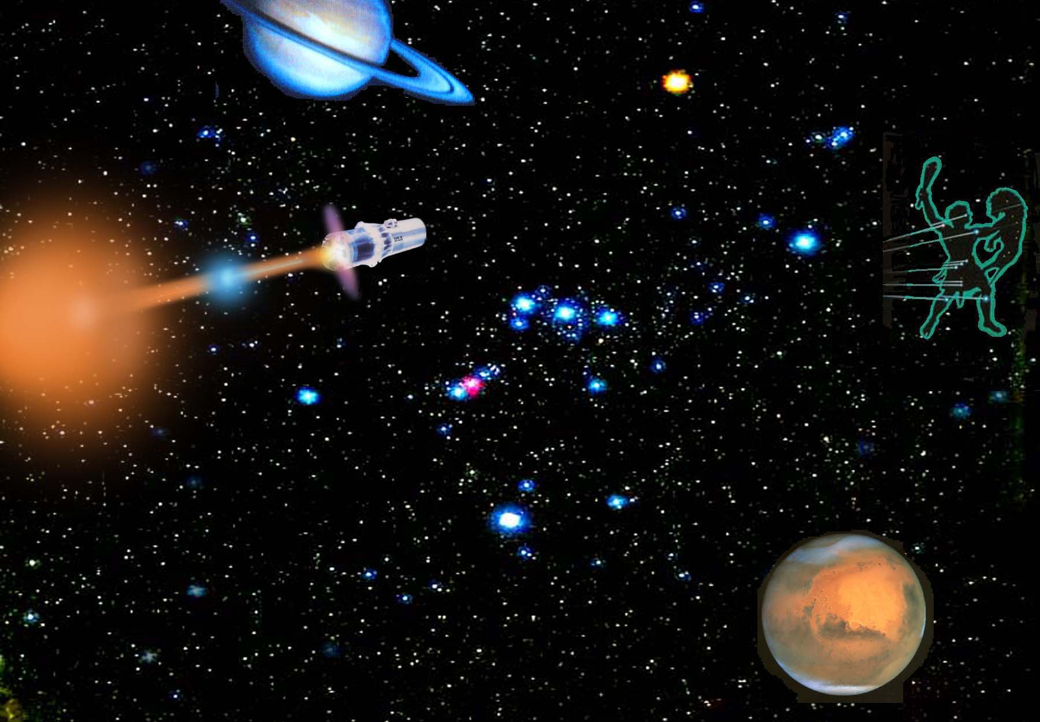

Fig. 4. Conceptual portrayal of a nuclear-explosion-driven ORION spaceship with the depiction of just two nuclear-propulsion detonations.

directed toward the alleviation of the "aqua alta" problem that was ever more frequently inundating the Venetian Lagoon.

By March 1972 the ruby holographic laser had been redirected to clean marble sculpture (Figure 6) by means of radiation-induced ablation in accordance with results from the radiation-hydrodynamic modeling of the earlier x-ray-beam nuclear-propulsion system. This came about at the suggestion of Lorenzo Lazzarini and Giulia Musumeci of the Venetian Soprintendenza in response to the unacceptable cleaning results on friable stone with conventional air-abrasive and chemical approaches (Figure 7).

This preamble to the formation of LACONA (more than a decade later by scientists at FORTH) came full circle (viz., back to Hedy Lamarr) with the entrance of an MGM competitor, Warner Brothers Films. At a 1977 Venice film festival event (a showing of

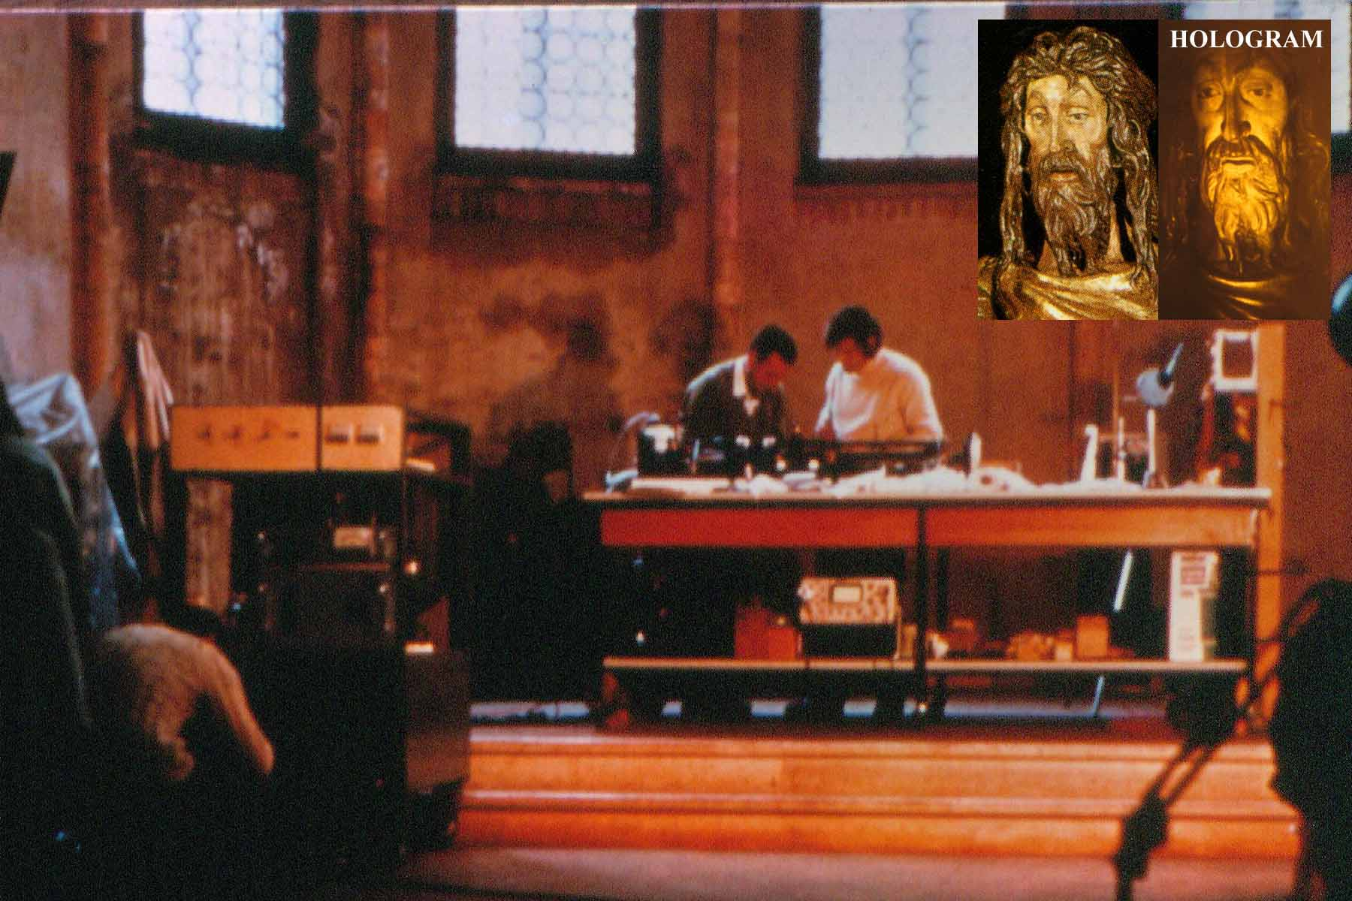

Fig. 5. Laboratorio San Gregorio site of the January 1972 archival holography project in Venice. The insets show the Donatello "San Giovanni" and its holographic reconstruction (2D).

“Clockwork Orange” in Asolo) Jack Warner, Jr. offered to divert a
associates, raised US$5000 toward the realization of such a project.
portion of his profits from “Clockwork Orange” to pay for a laser restoration demonstration. He, together with his friends and
Arch. Giancarlo Calcagno of the Soprintendenza selected the artwork to be the subject of the first full-scale laser-cleaning art-conservation effort. The piece he selected in the Porta della Carta was a marble relief depicting “The Last Supper”. It was approximately 60cm high and 180cm wide. After a protracted sequence of laser validation tests in the laboratory the actual laser restoration work took place in 1980 when a Nd:YAG laser (converted from the original ruby system as Nd:YAG had become available) was used to clean the marble relief in support of the overall Porta della Carta conservation effort.

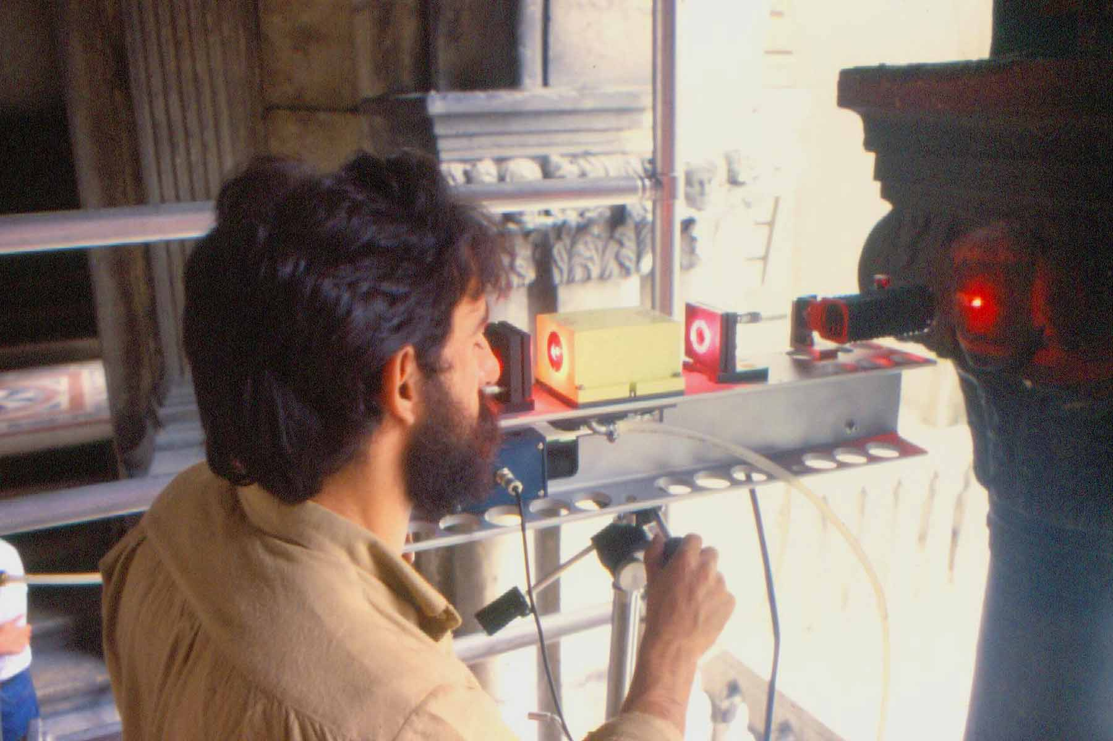

Fig. 6. Arch. Calcagno’s first in-situ laser cleaning demonstration.

As the heavy marble relief had been laid horizontally on its back for treatment, the laser was mounted on a beam above the artwork in order to avoid the use of turning optics (that were unable to withstand the laser fluence in that early era). The laser beam was directed vertically downward to impinge upon the marble surface. The laser head was attached to the supporting beam with a swivel
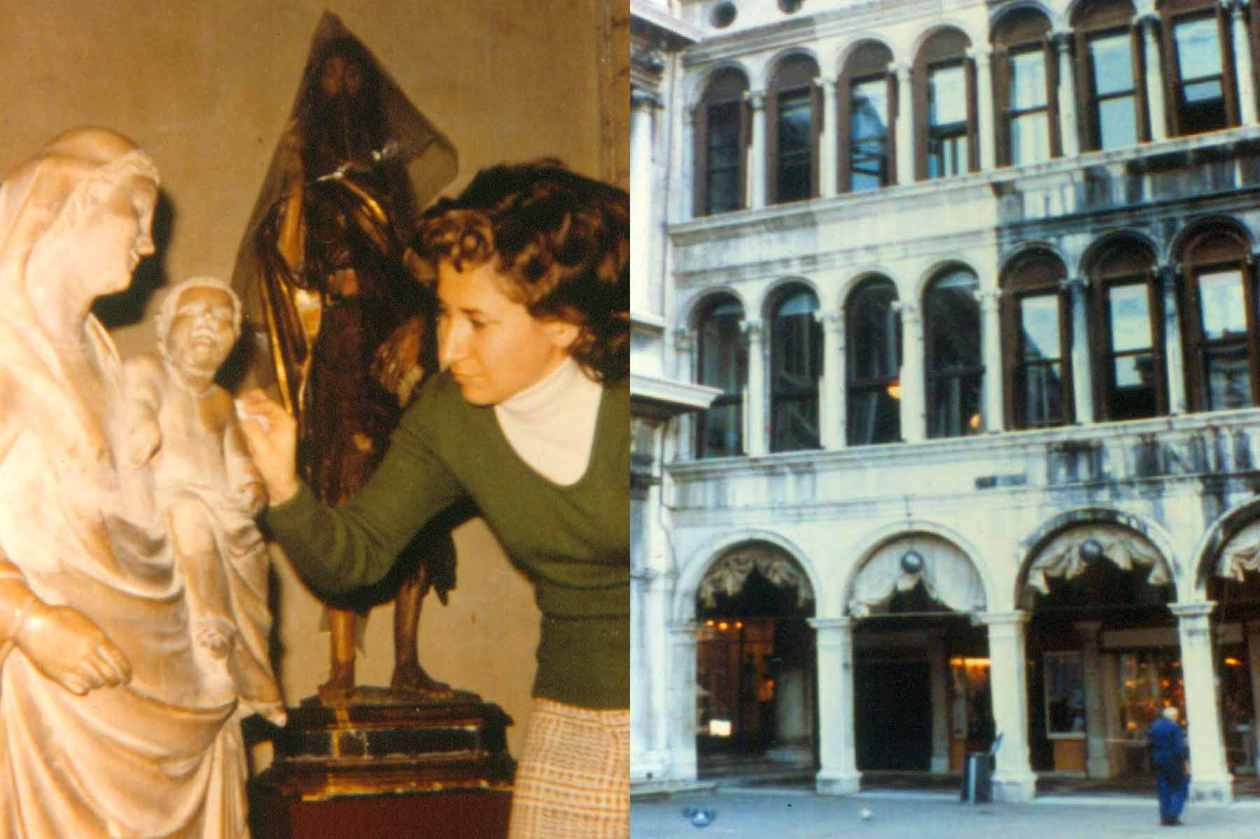

Fig. 7. Unsuccessful conventional-cleaning at Piazza San Marco.

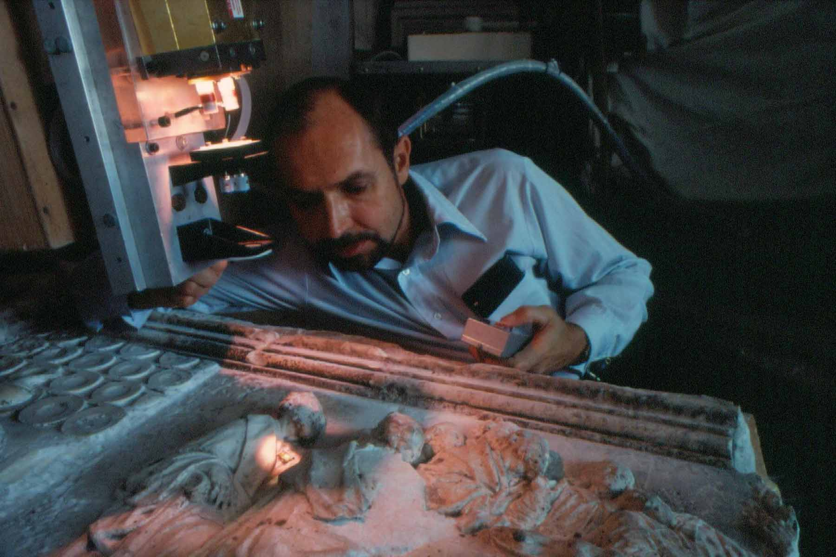

Fig. 8. The Porta della Carta of the Palazzo Ducale in Venice and a
vertically mounted laser cleaning a “Last Supper” marble relief.
joint so that the laser beam could be manually scanned across the surface. The laser functioned in the normal mode (400us) at 1J/pulse. In most areas a spot size of 3mm was employed. Figure 8 shows the Porta della Carta and the laser pointing downward onto
the relief.

Return to Hollywood and the cinema
A new Warner Brothers corporate office complex was constructed in the Los Angeles area while the laser work was proceeding in Venice. The following year (1981), with the completion of the central corporate tower of the Warner Center, the general contractor found that rubber cushioning used during shipping had discolored the tower’s South African granite veneer slabs. Chemical treatments that removed the stains also etched the stone and left it with a frosted appearance. Figure 9 (left side) shows the central tower of the Warner Center complex. The dark vertical stripes, as well as the horizontal bands at the top and bottom are of South African granite.

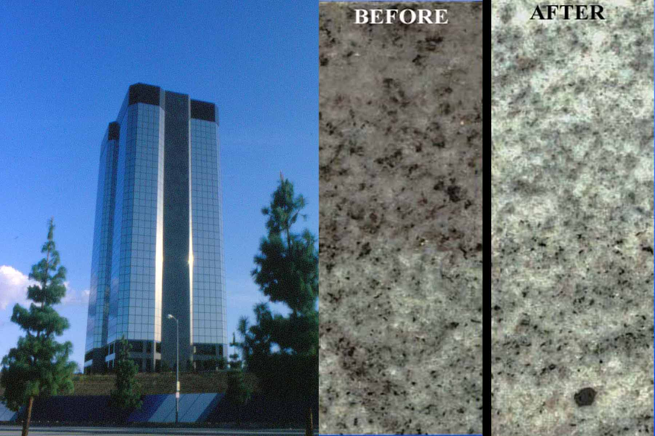

Fig. 9. Warner center tower with the prominent granite veneer horizontal bands and vertical stripes (left) and detail of laser treatment ("bleaching") of the stained granite (right).
As a last resort, the “Venetian” laser was sent to the Warner tower for a cleaning trial. At low fluxes and high fluences the laser induced optical damage in the mineral grains of the stone. The resulting cleavages within the mineral grains resembled the normal heterogeneity of granite, yet masked the in-depth chemical blemish. This approach was selected as the most suitable treatment. Consequently, good fortune (serendipity) made one further appearance when the “Venetian” laser repaid its debt to the cinema industry by removing the visual blemishes from the exterior granite of the corporate center after the failure of chemical cleaning techniques. Figure 9 (right side) shows the results of the laser irradiation of the blemished granite veneer.

Conclusion
Histories of developments in science and technology are replete with instances of unintended and/or unanticipated consequences. Sometimes such surprises are favorable. Often they bode disaster. All of the earliest pioneers of the laser have expressed bemusement at the laser’s entry into the field of art conservation practice (as well as its ubiquitous role in realms such as that of the audio CD and the video DVD). Most certainly, the art conservation connection is an “untended consequence” of investigations into the very diverse fields of spread-spectrum communications, deep-space nuclear propulsion, holographic plasma diagnostics, and archival holographic recording. In retrospect it is clear that laser surface divestment would have found its way into the field of art conservation at some point. However, the route that did lead initially to the laser in the arts is a testimonial to the tenacious punctuality with which serendipity invades the circuitry of technological progress. This particular geographical route to innovation, beginning (with Lamarr) and then returning to Vienna (with LACONA VI), is one more example (in a myriad of examples) illustrating that discovery seldom proceeds in a linear and predictable fashion.

Acknowledgements
Herbert York, Theordore Taylor, Morris Scharff, Edward Creutz, Keith Boyer, Donald Adrian, and Robert Willis are thanked for their oral histories of the ORION and ARGUS projects. Charles Townes, Ali Javan, Gordon Gould, William Bridges, Ralph Wuerker, and Arthur Schawlow are thanked for their oral histories of the invention of the laser and pulsed-laser holography. Lorenzo Lazzarini, Kenneth Hempel, and Giulia Musumeci are thanked for first suggesting the laser cleaning of stone sculpture. The author’s science teacher at Chaffey High School (Mr. Sweihardt) is thanked for arranging summer employment with project ARGUS at the U.S. Naval Ordnance Laboratory. Evelyn Lambert described the formation and operation of "The Friends of Venice" and raised the funds for the laser projects in Venice.

Much of the material in the above discourse was not published in a timely manner as an earlier manuscript (1978) was rejected (without review) by the editor of Studies in Conservation as he deemed laser-divestment cleaning “too hypothetical to be taken seriously”. Many of the technical, political, and financial barriers to progress in the activities outlined above were surmounted through the intervention of the Viennese/American, Walter Munk (Director Emeritus, Institute for Geophysics and Planetary Physics, Scripps Institution of Oceanography at the University of California, San Diego) and his wife, Judith Horton Munk.

